A000-Afr-Burkina Faso-Mask-Bwa-Nwantantay-20th century

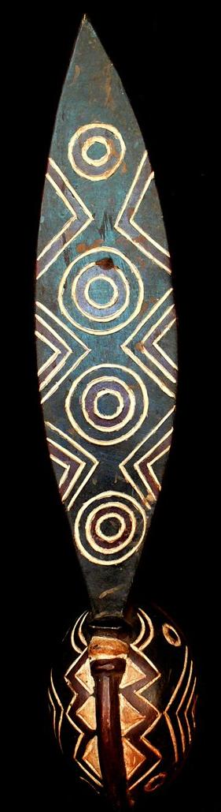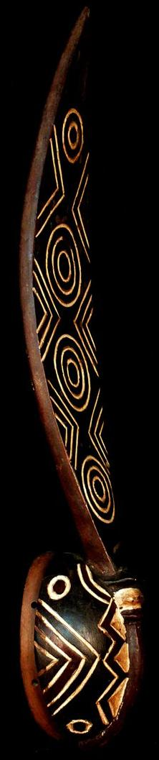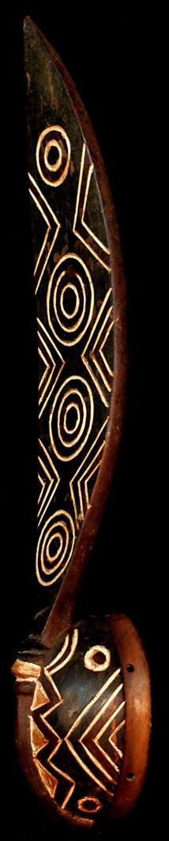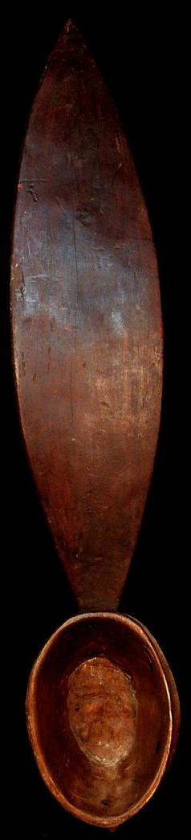

|  |  |
| --- | --- |
|  |  |

Size : 27.559 inches  
Weight: 1.303 pounds  
Material: Wood and kaolin pigment

A colorful Bwa plank mask, with superb geometric motifs on the plank in front and in the back, a round face showing a large curved appendage in the form of a bird beak and two circular eyes with concentric designs. Among the Bwa, this plank mask is known as a Nwantantay. It would have been worn on the head, tilting downward, fringed in a full-body raffia skirt, with the dancer peering through the opening in the mouth. Such masks were danced at the funerals of important members of the community, at the annual village purification ceremony.

It was recorded that Bwa masks as well as Nuna, Nunuma, and Waniama wooden masks represent a number of characters in the myths of their families and clans. Obviously, The offered mask represents a bird. Masks represent numerous animals including the antelope, bush buffalo, monkey, and bush pig. Water-dwellers include the crocodile, and fish of several types. The serpent, and insects, appear as do the butterfly, hawks and vultures. Several human characters appear, including the leper, and the crazy man and his wife. Other masks represent bush spirits in supernatural forms. The geometric patterns are also distinctive, and again almost all of the prototype Bwa symbols can be found, including the zigzag and checkerboard, common in initiation themes, and the beautiful multiple "X" patterns, which mimic the scarification designs found on the foreheads of initiated Bwa men. They may also have mythical meaning and They have a pedagogical purpose in the sense that these graphic patterns serve as didactic signs to teach the moral values of the community.

See photos of similar masks  in Christopher D., Roy  & Thomas G.B. Wheelock. Land of The Flying Mask. Art and Culture in Burkina Faso, Prestel, Munich, Berlin, London, New York, 2007. pp. 4, 51, 74,

